Magnetic Fastener Signature Banner
5/24/2023

Copy and paste the banner below:

-----------------------------------------------------------------------------------------------------------------------

Instructions on how to add to your signature

STEP 1: Copy the banner image above
STEP 2: Open your Outlook account, click “File” then click “Options’ then “Mail” from the left-hand menu.
STEP 3: Select “Create or modify signatures for messages.”

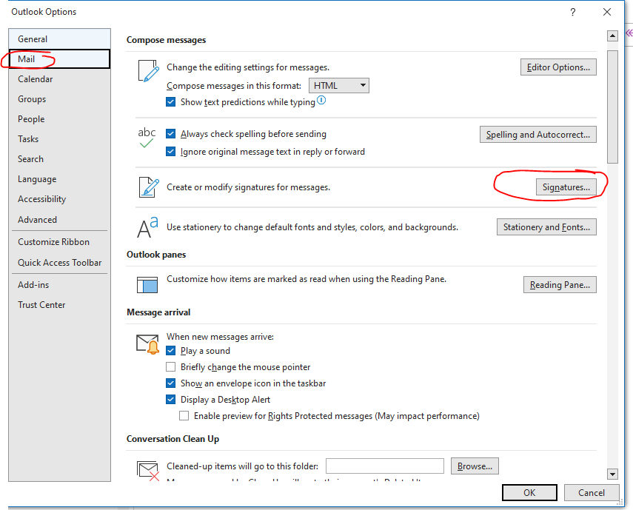

STEP 4: In your “Main” signature box paste the text and banner underneath your standard signature. You will one at least one line of space between your signature and the banner. (see below)

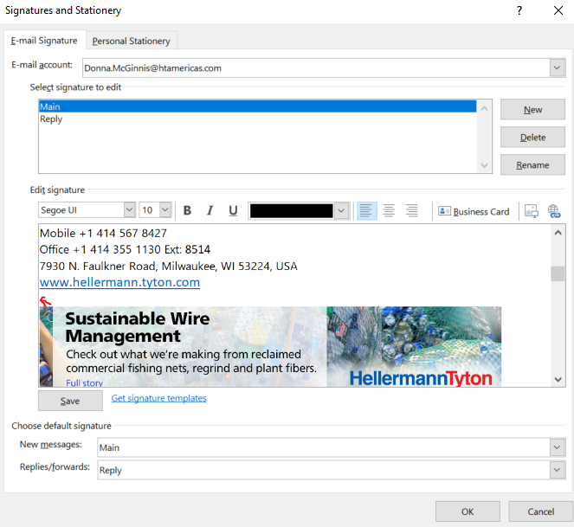

STEP 5: Click “OK” to save your updated Main signature and “OK’ once more to close out the signature menu.

STEP 6: Open Outlook and create a new message to confirm that the banner has been added correctly. It should look similar to below with the banner included below the signature. The banner has a hotlink to the product’s featured product page or other relevant page. You can view the url location by hovering over the banner. Once the email is sent, the hotlink will become clickable.

Need assistance? Contact Donna McGinnis: donna.mcginnis@htamericas.com.

This is how it should look when you send an email (this is an example, may not be actual banner shown below):

