[POST 1]
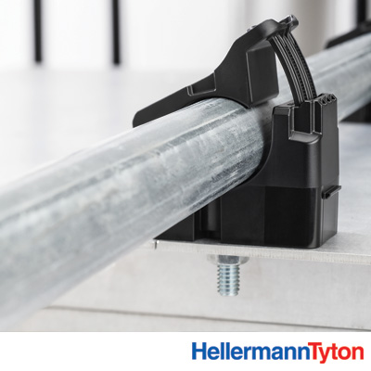

New solution for mounting conduit. Conduit clamps utilize HellermannTyton’s patented Ratchet Clamp platform, so they conveniently adjust to fit multiple conduit diameters. One-piece construction for quick installs on strut channels and threaded rods with no additional hardware. Check them out: link
#simplicity #adjustible #nohardware

[POST 2]
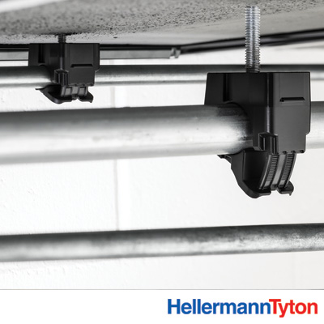

These conduit clamps utilize HellermannTyton’s patented, size-adjustable Ratchet Clamp platform. For strut and threaded rod applications, the one-piece clamp goes on without any additional hardware. A bolt-mount version is also available. All clamps can be preloaded to save a critical step at the installation site. Learn more here: link
#simplicity #adjustible #nohardware

[POST 3]

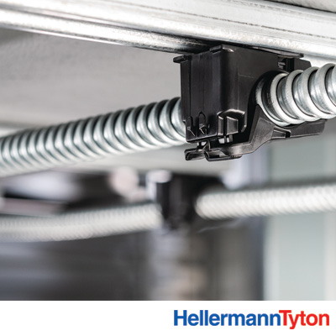

These conduit clamps utilize HellermannTyton’s patented, size-adjustable Ratchet Clamp platform. For strut and threaded rod applications, the one-piece clamp goes on without any additional hardware. A bolt-mount version is also available. All clamps can be preloaded to save a critical step at the installation site. Learn more here: link
#simplicity #adjustible #nohardware

