[POST 1]
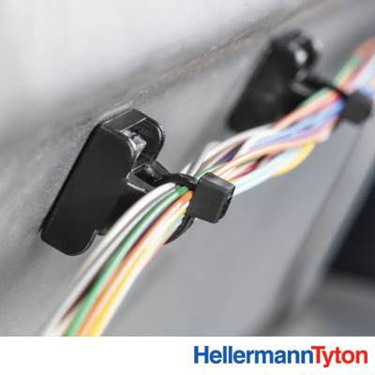

Did you hear? We have magnetic wire management products from HellermannTyton. They’re ultra-strong – made with the world’s most powerful neodymium magnets. So they stay where you put them. They are forever reusable, too. Try them out. Have a pull-off contest with coworkers. Then contact your local distributor to load up on these handy routing aids. Link

#wiremanagement #magdaddy #cablerouting #reusable #sustainable #fastener #madeinamerica

[POST 2]
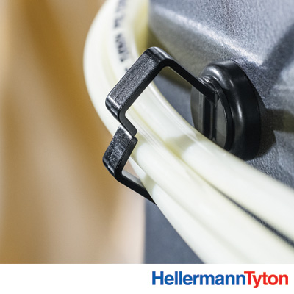

Magnetic wire mounts? Yes! These neodymium magnet-powered routing aids feature the strongest magnets in the world. No drilling, welding, adhesive or extra mounting hardware needed. That makes them handy for quick wire routing along steel surfaces. They also make a great “third hand” for temporary routing assistance. Learn more: Link

#wiremanagement #magdaddy #cablerouting #reusable #sustainable #fastener #madeinamerica

[POST 3]

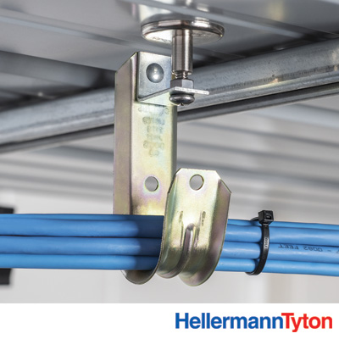

Routing wires or tubes along an industrial ceiling? Consider these rare-earth magnetic mounts. No holes to drill, no clamps or additional hardware. Just stick it in place and move on. Neodymium magnets lose less than 10 percent of their incredible strength over 100 years, so you should be okay for a while. More here: Link

#wiremanagement #magdaddy #cablerouting #reusable #sustainable #fastener #madeinamerica

